**UNIT-IV**

**Protective Relays**

Protective relay work as a sensing device, it senses the fault, then known its position and finally, it gives the tripping command to the circuit breaker. The circuit breaker after taking the command from the protective relay, disconnect the faulted element.

By clearing the fault fast with the help of fast-acting protective relay and associated circuit breaker, the damage to the apparatus is reduced, and the resultant hazards like fire, the risk of the life are reduced, by removing the particularly faulted section.

But the continuity of supply is maintained, though remaining healthy section, by clearing the fault fast, fault arising time is reduced, and therefore the system can be restored to the normal state sooner. Hence the transient state stability limit of the system is greatly improved, permanent damage to the equipment is avoided, and the possibility of developing most simple fault such as single phase-to-ground into most severe fault such as double phase-to-ground fault is reduced.

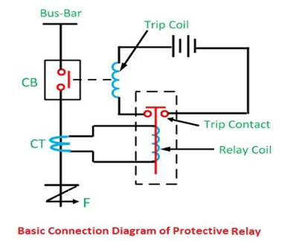

Fig.1

The fault can only be reduced if the protective relay is reliable, maintainable and sensitive enough to distinguish between normal and abnormal condition. The relay must come into action whenever there is a fault and must not operate if there is no fault.  Some relays are used for the protection of the power system.  Some of them are primary relay meaning that they are the first line of defence. Such relays sense the fault and send a signal to the proper circuit breaker to trip and clear the fault.

The fault may not be cleared if the circuit breaker fails to open or relay maloperates. The relay failure is because of three reasons such as wrong setting, bad contacts and open circuit in the relay coil. In such cases,  the second line of defence is provided by the backup relays. The backup relay has longer operating time, even though they sense the fault along with the primary relays.

To attain the desired reliability, the power system network is divided into two different protection zones. The overall system protection is divided into different protection zones. They are generator protection, transformer protection, bus protection, transmission line protection and feeder protection.

**Impartent terms related to relays:**

**Energizing Quantity** – It is an electrical quantity which is a merger of voltage or current or either voltage or current alone, required for the operation of the relay.

**Trip Circuit** – It is the circuit that controls the circuit breaker for opening operation and comprises of trip coil, relay contacts, auxiliary switch battery supply, etc.

**Operating Force or Torque** – It is a force which tends to close the relay contacts.

**Restraining Force or Torque** – It is a force or torque, which opposes the torque and tends to interrupt the closure of the relay contacts.

**Setting** – It is an actual value of the energizing quantity at which the relay is made to operate under given conditions.

**Pick Up** – A relay is said to pick up when it moves from the off position to the on position or the operation of the relay is called the relay pick-up.

**Operating or Pickup Relay** – It is the value of the actuating quantity (current or voltage) which is on the threshold above which the relay operates and closes its contacts. If the current in the relay is less than the pickup value, the relay does not operate, and the breaker operates by it remain in the closed position.

**Drop Out or Reset Level** – This is the value of the current or voltage, etc. below which a relay opens its contacts and comes back to its original position. The ratio of the drop-out voltage or reset value to the pick or operating value is called the drop-out or reset ratio.

**Reset time** – It is given by the time which passes away between the instant when the current or voltage (actuating quantity) becomes less than the reset value at the time when the relay contacts are closed.

**Fault Clearing Time-** It is the time between the existence of a fault and at the time of final arc quenching in a circuit breaker is called the fault clearing time.

**Breaker Time** – It is the time between termination of fault and final arc quenching in a circuit breaker is called the breaker time.

**Relay Time** – The interval between the existence of fault and closure of relay contacts is called the relay time.

**Reach** – It is defined as the limiting distance covered by the protection, the fault beyond which are not within reach of the protection and should be covered by the other relay.

**Maximum torque angle:** the design angle of the relay that will yield maximum torque.

**Current setting:** Adjusting the pickup current to a pre-determined value is called as current setting.

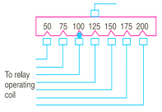

This is achieved by tapping the relay coil. These taping values are expressed in terms of percentage full load rating of CT with which the relay is activated. By varying the number of turns the activating quantity is varied, that varies the time of operation of relay to close the trip.

Pick up current = Rated secondary current of CT x current setting

**Plug Setting Multiplier (PSM):** it is the ratio of fault current in the relay coil to the pickup current.

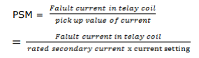

**Time/PSM curve**: the curve between the time of operation and PSM of a relay. Horizontal axis: PSM representing the no. of times the relay current is in excess of current setting. Vertical axis calibrated in terms of time required for relay operation.

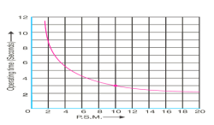



**Time setting Multiplier (TSM):** adjusting the time of operation of the relay using time setting dial is called time setting multiplier. The dial is calibrated in steps; these values are multipliers to be used to convert the time curve into the actual operating time.

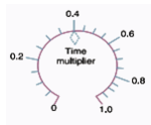

**Actual relay operating time = TMS x operating time from time/PSM curve.**

Procedure to calculate the relay operating time:

1. Convert the fault current into relay coil current using CT ratio.

2. Calculate PSM, i.e., Express the relay current as multiple of current setting.

3. From time/PSM curve of rely, read the time of operation for the calculated PSM.

4. Determine the actual time of operation by multiplying the above time of relay using TSM.

**Example :** **Determine the time of operation of a 5-ampere, 3-second overcurrent relay having a current setting of 125% and a time setting multiplier of 0·6 connected to supply circuit through a 400/5 current transformer when the circuit carries a fault current of 4000 A. Use the curve shown in above time/PSM curve fig.**

Solution: Rated secondary current of C.T. = 5 A

Pickup current = 5 × 1·25 = 6·25 A

Fault current in relay coil = 4000 5 400 × = 50 A

∴ Plug-setting multiplier (P.S.M.) = 50/6.25=8 Corresponding to the plug-setting multiplier of 8 (See Fig. above time/PSM curve fig ), the time of operation is 3.5 seconds.

∴ Actual relay operating time = 3·5 × Time-setting

= 3·5 × 0·6 = 2·1 seconds

### ****4.1 Fundamental Requirements of Protective Relay:****

The principal function of Protective Relay is to cause the prompt removal from service of any element of the [power system](https://www.eeeguide.com/category/power-system/) when it starts to operate in an abnormal manner or interfere with the effective operation of the rest of the system. In order that protective relay system may perform this function satisfactorily, it should have the following qualities :

1. **Selectivity**
2. **Speed**
3. **Sensitivity**
4. **Reliability**
5. **Simplicity**
6. **Economy**

**1. Selectivity: It is the ability of the protective system to select correctly that part of the system in trouble and disconnect the faulty part without disturbing the rest of the system.**

**2. Speed:** The relay system should disconnect the faulty section as fast as possible for the following reasons

* **Electrical apparatus may be damaged if they are made to carry the fault currents for a long time.**
* **A failure on the system leads to a great reduction in the system voltage. If the faulty section is not disconnected quickly, then the low voltage created by the fault may shut down consumers motors and the generators on the system may become unstable.**
* **The high speed relay system decreases the possibility of development of one type of fault into the other more severe type.**

**3. Sensitivity:** It is the ability of the relay system to operate with low value of actuating quantity.

Sensitivity of a relay is a function of the volt-amperes input to the coil of the relay necessary to cause its operation. The smaller the volt-ampere input required to cause relay operation, the more sensitive is the relay. Thus, a 1 VA relay is more sensitive than a 3 VA relay. It is desirable that relay system should be sensitive so that it operates with low values of volt-ampere input.

**4. Reliability:**It is the ability of the Protective Relay system to operate under the pre-determined conditions. Without reliability, the protection would be rendered largely ineffective and could even become a [liability](http://www.allaboutcircuits.com/).

**5. Simplicity:**The relaying system should be simple so that it can be easily maintained. Reli­ability is closely related to simplicity. The simpler the protection scheme, the greater will be its reliability.

**6. Economy:** The most important factor in the choice of a particular protection scheme is the economic aspect. Sometimes it is economically unjustified to use an ideal scheme of protection and a compromise method has to be adopted. As a rule, the protective gear should not cost more than 5% of total cost. However, when the apparatus to be protected is of utmost importance (e.g. generator, main transmission line etc.), economic considerations are often subordinated to reliability.

# 4.2 Zones of protection in Power System:

**Definition:** Protection zone is defined as the part of the [power system](http://circuitglobe.com/power-system.html) which is protected by a certain protective scheme. It is established around each power system equipment. When the fault occurs on any of the protection zones then only the circuit breakers within that zone will be opened. Thus, only the faulty element will be isolated without disturbing the rest of the system.

The protection zone cover the entire power system, and no part of the equipment is left unprotected. It usually consists one or more element of the power system. The protection zone of the power system mainly depends upon the rating of the machine, its location, the probability of faults and abnormal condition of the equipment.

## Overlapping Zone of Power System

If there were no overlapping in the protective zone, then the failure occurs in the equipment will not lie in any one of the zones and hence no circuit breaker would be tripped. The fault occurs in the unprotective system will damage the equipment and hence disturb the continuity of the supply.

The figure below shows a certain amount of overlapping between the protective zones.

[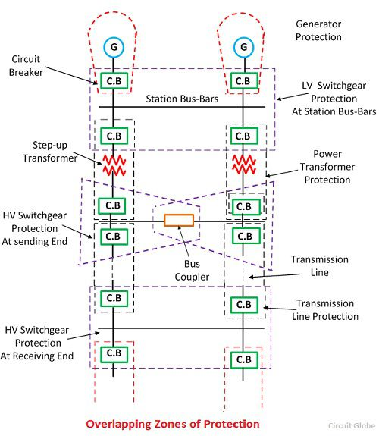](http://circuitglobe.com/wp-content/uploads/2016/12/protection-zones.jpg)

Fig.2

The probability of failure in the overlap region is very small. But the overlap region will cause the tripping of the more [circuit breake](http://circuitglobe.com/circuit-breaker.html)r than the minimum necessary for the disconnection of the faults region. Because when the fault occurs in any one of the two overlapping regions than the breaker of both the region will be opened, and the systems are isolated.

Consider the two protective zone A and B which will overlap each other. The X is the fault occurs in the zone B, and due to this fault, the circuit breakers of zone B tripped along with the C (circuit breaker). The relay of the zone B will also trip the circuit breaker of zone A for other faults in the zone B which occurs to the right of the C (circuit breaker). Hence the unnecessary tripping of the breaker can be tolerated only in the particular region.

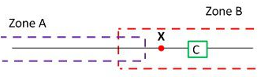

Fig.3

The scheme which senses the fault of any of the certain unit will have a high degree of sensitivity and it also has the adaptability of the fast speed of operation.

# 4.3 Primary & Backup Protection :

## Primary Protection

The main protection or primary protection is the first line protection which provides quick-acting and selective clearing of a fault within the boundary of the circuit section or element it protects. The main protection is provided in each section of an electrical installation.

## Backup Protection

The backup protection provides the back up to the main protection whenever it fails in operation or its cut out for repairs. The backup protection is essential for the proper working of the electrical system. The backup protection is the second line of defence which isolates the faulty section of the system in case the main protection fail to function properly. The failure of the primary protection occurs because of the failure of the DC supply circuit, current or voltage supply to relay circuit, relay protective circuit or because of the [circuit breaker.](http://circuitglobe.com/circuit-breaker.html)

The backup protection may be provided either on the same circuit breaker which would be normally opened by the main protection or in the different circuit breaker. The backup protection is mainly used where the main protection of the adjacent circuit is unable to backup the main protection of the given circuit. Sometimes for simplification, the backup protection has a low sensitivity and operated over a limited backup zone.

**Example:**Consider the remote backup protection is provided by a small time graded relay, as shown in the figure below. Let F be the fault occur on relay R4. The relay R4 operates the circuit breaker at D and isolate the faulty section. Now if the circuit breaker D fails to operate, the faulty section would be isolated by the operation of the relay R3 at C.

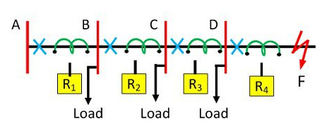

Fig.4

The use of the backup protection depends on the economics and technical consideration. The backup protection usually for the economic reason not so fast as the main protection.

**4.4 Operating Principle of Protective Relay schemes:**

The working of the relay is either depends on the electromagnetic attraction or electromagnetic induction. The electromagnetic attraction type relay has a solenoid which is attracted towards the poles of the electromagnet. This relays works on both the AC and DC supply.

The electromagnetic induction type relay uses the induction motor inside which the torque is generated by the process of electromagnetic induction. Such type of relays works only on ac quantities.

**Classification of Relays:**

**Based on the construction and principle of operation:**

1. Electromagnetic relays. They are activated by A.C. or D.C. quantities.

2. Electro-thermal relays. Thermal protection using Bi-metallic strip.

3. Physico-electric relays. Change in the physical parameters (Buchholz relay).

4. Static relays. use solid state devices for their operation.

5. Microprocessor based relays. Use VLSI technology.

**Based on their application:**

1. Over current relays. Operate when the activating quantity (current) rises above a specified value.

2. Under voltage relay. Operates when the activating quantity (voltage) falls below a specified value.

3. Distance relays. Its operation depends upon V/I ratio.

4. Differential relays. Its operation depends upon comparison of two or more electrical quantities.

5. Directional relays.

6. Under frequency relays.

**Based on time of operation:**

1. Instantaneous relays. Operation takes place after a small interval of time that is negligible.

2. Definite time relays. Its operation is independent of magnitude of activating quantity.

3. Inverse time relays. Their time of operation is inversely proportional to the magnitude of the activating quantity

**Electromagnetic relays**:

The relay coil on carrying the relay current produces electromagnet on which they are wound. The activating quantities may be AC or DC. They are categorized into (a) Attraction type and (b) Induction type.

**Electromagnetic Attraction Relays:** operate by virtue of an armature being attracted to the poles of an electromagnet or a plunger being drawn into a solenoid. Such relays may be actuated by D.C. or a.c quantities.

The basic types are:

1. Attracted armature type. 2. Solenoid type. & 3. Balanced beam type

**1.Attracted armature type relay:**

**Construction:** The attracted armature type relay consists of a laminated electromagnet carrying a coil and a pivoted laminated armature. The armature is balanced by a counter weight and a pair of spring contact fingers at its free end.

**Operation:** under normal operation conditions the current through the relay coil is such that the counter weight holds the armature in open position i.e., it withstand and hold the magnetic attraction of the electromagnet. when fault occur, the current through the relay coil increases sufficiently to attract the armature upwards making the stationary contacts attached to the relay frame and closes the trip circuit that results in operating of CB and faulty section is isolated.

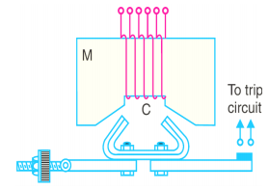

**2.Solenoid type relay:**

**Construction:** this is a plunger model. It consists of a solenoid and an iron plunger, where the iron plunger moves freely through the axis of the solenoid or suspended by springs.

**Operation:** under normal operation conditions the current through the relay coil is such that it holds the plunger by gravity or springs. When fault occurs, the current through the relay coil becomes more than the pickup value, causing the plunger to be attracted by the solenoid. Thus closing the trip circuit and the faulty circuit is disconnected by CB operation.

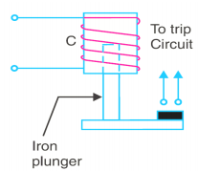

**3.Balancedbeamtyperelay:**

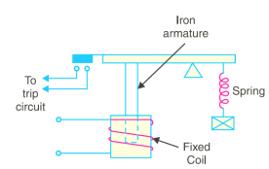  
**Construction:** it consists of an iron armature fastened to a balanced beam. The beam is held in horizontal position by a spring at one end and at the other end a plunger type arrangement is made such that the iron bar is suspended along the axis of the relay coil and the trip closing mechanism is also provided at this end.

**Operation:** under normal operating conditions the iron armature is held horizontally with the help of spring. When fault occurs the current in the relay coil exceeds the pickup value and attracts the iron plunger that closes the trip circuit and makes the CB to isolate the faulty section.

## Electromagnetic Induction Relays:

             The **induction type relays** are also called **magnitude relays**.These relays work on the principle of the [induction motor](http://www.electricalengineeringinfo.com/2017/09/three-phase-induction-motor-working-principle-construction.html) or an energy meter.In these relays, a metallic disc is allowed to rotate between the two electromagnets.The coils of the electromagnets are energised with the help of alternating currents.

           The torque is produced in **Induction relays** due to the interaction of one alternating flux with eddy currents induced in the rotor by another alternating flux.The two fluxes have the same frequency but are displaced in time and space. As the interaction of alternating fluxes is the base of operation of **Induction relays**, these are not used for the d.c. quantities.These are widely used for protective relaying involving only a.c. quantities.

### Types of Induction Relays:

        Based on the construction, the various **types of induction relays**are:                   
**1)Shaded pole Relays**  
**2)Watt-hour meter Relays**  
**3)Induction cup Relays**

         Before studying these types in detail, let us derive the torque equation for the **induction type relays**, which is same for all the **three types of induction relays.**

### Torque Equation for Induction Type Relays:

         As mentioned earlier, the alternating currents supplied to two electromagnets produce the two alternating fluxes φ1 and φ2.These two fluxes have the same frequency but they have a phase difference of α in between them such that φ2 leads φ1.Thus the two fluxes can be mathematically expressed as,

φ1 = φ1m sin ωt

                               φ2 = φ2m sin (ωt+α)

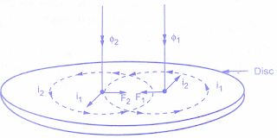

These alternating fluxes cause the induced e.m.f.s in the rotor. Due to the induced e.m.f.s, the eddy currents i1 and i2 are circulated in the disc.The two eddy currents react with each other to produce a force which acts on the rotor.

           The figure above shows how the forces are produced in a section of the rotor due to the alternating fluxes.The instant considered to show the various quantities is when both the fluxes are directed downwards and are increasing in magnitude.The induced eddy currents lag behind the respective fluxes by 90⁰.

**Assumption:** The parts of the rotor in which rotor currents flow have negligible self-inductance and hence the rotor currents are in phase with the respective induced voltages.The induced voltages are proportional to the rate of change of fluxes and hence the eddy currents also are proportional to the rate of change of fluxes. Hence we can write,

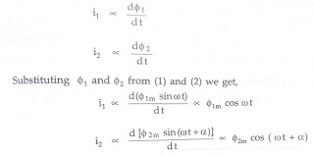

The forces are produced due to the interaction of φ1 with i2 and φ2 with i1.

                                           ∴      F1  ∝ φ1 i2

                                          and    F2 ∝ φ2 i1

        The directions of F1 and F2 can be obtained by [Flemings left-hand rule](https://en.wikipedia.org/wiki/Fleming%27s_left-hand_rule_for_motors).It can be seen from the above figure that the two forces are acting in the opposite directions and hence the net force acting on the disc is proportional to the difference between the two forces.

                                              ∴      F  ∝  F2 - F1

                                               ∴     F  ∝  φ2 i1 - φ1 i2

 Substituting the proportional expressions of φ1, φ2, i1, i2 in the above equation we get,

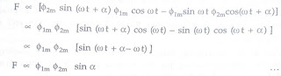

The equation above gives the net force acting on the disc which is proportional to sin ∝.

         Substituting the r.m.s values of the fluxes instead of maximum values we get,

                                              F ∝ φ1 φ2 sin ∝

        It is important to note that the net force or torque acting on the disc is same at every instant.The action of **Induction relay**under such force is free from vibrations.

         It can be observed from the above equation that if ∝ is zero then the net force is zero and disc cannot rotate.Hence there must exist a phase difference between the two fluxes.The torque is maximum when the phase difference ∝ is 90°.

        The direction of the net force which decides the direction of rotation of disc depends on which flux is leading the other.In practice, various constructions are used to produce phase displacement between the two fluxes.

**Shaded Pole Type Induction Relay:**

          The construction of **Shaded Pole Type Induction Relay** is shown in below figure.

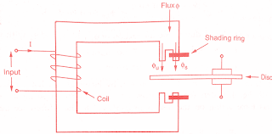

It consists of an aluminium disc which is free to rotate in an air gap of an electromagnet.The part of pole face of each pole is shaded with the help of copper band or ring.This is called shading ring.The total flux φ produced due to the alternating current split into two fluxes displaced in time and space due to the shading ring.

Due to the alternating flux, e.m.f gets induced in the shading ring.This e.m.f drives the currents causing the flux to exist in shaded portion.This flux lags behind the flux in the unshaded portion by angle ∝.

T ∝ φs φu sin ∝                     (where   T = Torque )

Assuming fluxes φs   and φu to be proportional to the current I in the relay coil we can write,

                                                T ∝ I² sin ∝

**Watthour Meter Type Induction Relay:**

             The construction of **Watthour Meter Type Induction relay** is similar to the watthour meter which is very popularly used everywhere.Thus relay has double winding structure.The arrangement is shown in the figure below.

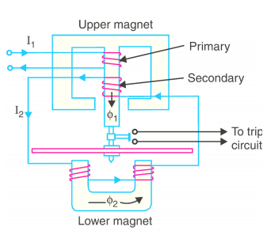

It consists of two magnets, one E shaped magnet and other U shaped magnet.The disc is free to rotate in between these two magnets.The upper E shaped magnet carries both primary winding which is relay coil and the secondary winding.The primary carries the relay current I1 which produces the flux φ1.The e.m.f gets induced in the secondary due to this flux.This drives current I2 through secondary.

            Due to this current I2, flux φ2 gets produced in the lower magnet.This flux lags behind the main flux φ1 by an angle ∝.Due to the interaction of these two fluxes, the torque is exerted on the disc and disc rotates.

         Assuming that the entire flux φ1 enters the disc from upper magnet and entire flux φ2 enters the disc from lower magnet, we can write,

                                       T ∝ φ1 φ2 sin ∝

        In **Watthour Meter Type Induction relay**, the tapping can be provided on the primary.With the help of this suitable number of primary turns can be selected and hence current setting can be adjusted.Most of the**induction relays** are of this type.

        An important feature of **Watthour Meter Type Induction relay** is that its operation can be controlled by opening or closing of the secondary winding.It is opened, no current can flow through secondary hence flux φ2 cannot be produced and hence no torque can be produced.Thus relay can be made inoperative opening the secondary winding.

### Induction Cup Relay:

       The construction of **induction cup relay** is very similar to an [induction motor](http://www.electricalengineeringinfo.com/2017/09/three-phase-induction-motor-working-principle-construction.html) as shown in below figure.

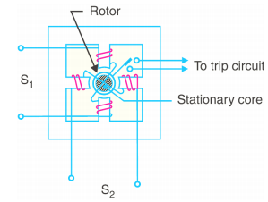

The stator consists of two, four or more poles.These are energized by the relay coils.The figure below shows 4 pole structure and the two pairs of coils. The coils 1 and 1' are connected while the coils 2 and 2' are connected to form two pairs of coils.The rotor is hollow cylindrical cup type in structure. Compared to [induction motor](http://www.electricalengineeringinfo.com/2017/09/three-phase-induction-motor-working-principle-construction.html) the difference is that in **induction cup relay** the rotor core is stationary and only rotor conductor portion is free to rotate about its axis.

         The currents and respective fluxes produced by the two pairs of coils are displaced from each other by angle ∝. Thus the resultant flux in the air gap is rotating.So [rotating magnetic field](http://www.electricalengineeringinfo.com/2016/12/rotating-magnetic-field-in-synchronous-machines-how-to-produce.html) is produced by two pairs of coils. Due to this, eddy currents are induced in the cuptyperotor.   
  
          These currents produce the flux. The interaction of the two fluxes produce the torque and the rotor rotates in the same direction as that of rotating magnetic field.A control spring and the back stop carried on an arm attached to the spindle of the cup, are responsible to prevent continuous rotation

**Over Current Relay**

## Working Principle of Over Current Relay

In an **over current relay**, there would be essentially a current coil. When normal current flows through this coil, the magnetic effect generated by the coil is not sufficient to move the moving element of the relay, as in this condition the restraining force is greater than deflecting force. But when the current through the coil increased, the magnetic effect increases, and after certain level of current, the deflecting force generated by the magnetic effect of the coil, crosses the restraining force, as a result, the moving element starts moving to change the contact position in the relay. Although there are different **types of over current relays** but basic **working principle of over current relay** is more or less same for all.

## Types of Over Current Relay

Depending upon time of operation, there are various **types of Over Current relays**, such as,

1. **Instantaneous over current relay**.
2. **Definite time over current relay**.
3. **Inverse time over current relay**.

**Inverse time over current relay** or simply **inverse OC relay** is again subdivided as **inverse definite minimum time** (IDMT), **very inverse time**, **extremely inverse time over current relay** or **OC relay**.

**1.Instantaneous Overcurrent Relay**

The relay has no intentional time delay for operation. The contacts of the relay are closed instantly when the current inside the relay rises beyond the operational value. The time interval between the instant pick-up value and the closing contacts of the relay is very less.

The most significant advantage of the instantaneous relay is that it has low operating time. It starts operating instantly when the value of current is more than the relay setting. This relay operates only when the impedance between the source and the relay is less than that provided in the section.

The most important feature of the relay is their speed of operation. The relay protects the system from earth fault and also used for protecting the system from circulating current. **The instantaneous overcurrent relay is placed in the outgoing feeder.**

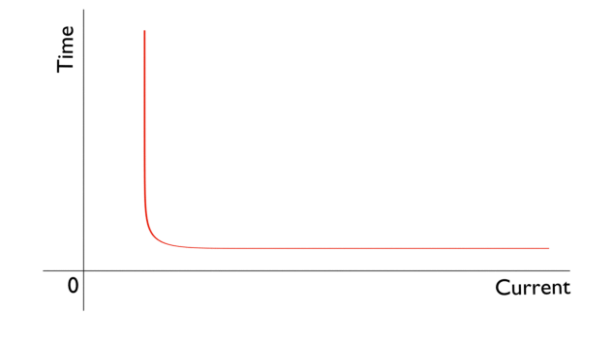

### 2.Definite Time Over Current Relay

This relay is created by applying intentional time delay after crossing pick up the value of the current. A **definite time overcurrent relay** can be adjusted to issue a trip output at an exact amount of time after it picks up. Thus, it has a time setting adjustment and pickup adjustment.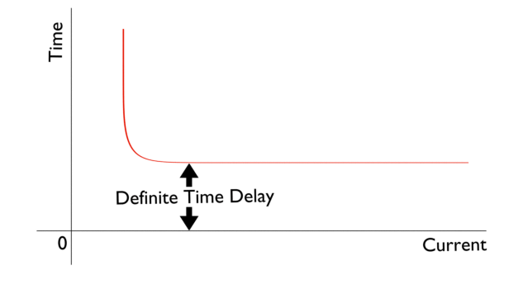

**3.Inverse time over current relay**.

The relay operates only when the magnitude of their operating current is inversely proportional to the magnitude of the energize quantities. The operating time of relay decreases with the increases in the current. The operation of the relay depends on the magnitude of the current.

The characteristic curve for the relay is shown in the figure below. The relay will not operate when the value of current is less than the pick value. The relay is used for the protection of the distribution lines. **The inverse time relay is of three types.**

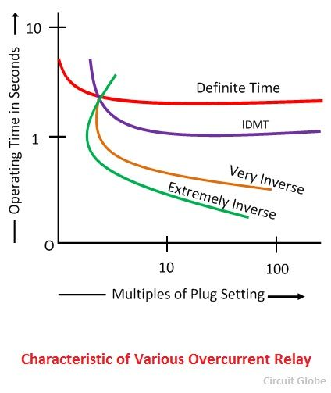

**3.1 Inverse Definite Minimum Time Relay**

The relay whose operating time is approximately proportional to the fault current is known as the IDMT relay. The operating time of the relay is maintained by adjusting the time delay setting. The IDMT relay uses the electromagnetic core because it can easily saturate for the current having larger magnitude than pick up current. **The relay is used for the protection of the distribution line.**

**3.2 Very Inverse Relay**

The inverse characteristic of the relay is more than the IDMT. **Such type of relay is used in the feeder and on long transmission lines.** The relay is used in the places where there the magnitude of the short-circuit current fall rapidly because of the large distance from the source. It is used for sensing the fault current which is free from the fault location.

**3.3 Extremely Inverse Relay**

The characteristic time of the relay is extremely large as compared to the IDMT and the Very inverse relay. **This relay is used for protecting the cable, transformer, etc.** The relay can operate instantly when the pickup value of the current is more than the relay setting time. The relay provides faster operation even under the fault current.  **It is used for sensing the overheating of the machines.**

**Induction Type Overcurrent Relay ( non-directional):**

This type of relay works on the induction principle and initiates corrective measures when current in the circuit exceeds the predetermined value. The actuating source is a current in the circuit supplied to the relay from a current transformer. These relays are used on a.c. circuits only and can operate for fault current flow in either direction.

Constructional details:Fig. Below shows the important constructional details of a typical nondirectional induction type overcurrent relay. It consists of a metallic (aluminium) disc which is free to rotate inbetween the poles of two electromagnets. The upper electromagnet has a primary and a secondary winding. The primary is connected to the secondary of a C.T. in the line to be protected and is tapped at intervals. The tappings are connected to a plug-setting bridge by which the number of active turns on the relay operating coil can be varied, thereby giving the desired current setting. The secondary winding is energised by induction from primary and is connected in series with the winding on the lower magnet. The controlling torque is provided by a spiral spring.

The spindle of the disc carries a moving contact which bridges two fixed contacts (connected to trip circuit) when the disc rotates through a pre-set angle. This angle can be adjusted to any value between 00 and 3600 . By adjusting this angle, the travel of the moving contact can be adjusted and hence the relay can be given any desired time setting.

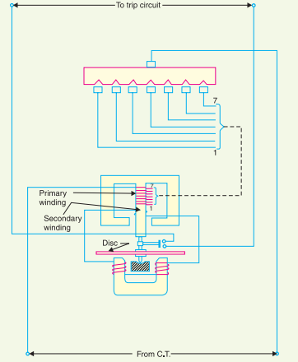

Operation. The driving torque on the aluminium disc is set up due to the induction principle as discussed earlier. This torque is opposed by the restraining torque provided by the spring. Under normal operating conditions, restraining torque is greater than the driving torque produced by the relay coil current. Therefore, the aluminium disc remains stationary. However, if the current in the protected circuit exceeds the pre-set value, the driving torque becomes greater than the restraining torque. Consequently, the disc rotates and the moving contact bridges the fixed contacts when the disc has rotated through a pre-set angle. The trip circuit operates the circuit breaker which isolates the faulty section.

**Induction Type Directional Power Relay:**

This type of relay operates when power in the circuit flows in a specific direction. Unlike a *nondirectional overcurrent relay, a directional power relay is so designed that it obtains its operating torque by the interaction of magnetic fields derived from both voltage and current source of the circuit it protects. Thus this type of relay is essentially a wattmeter and the direction of the torque set up in the relay depends upon the direction of the current relative to the voltage with which it is associated.

Constructional details:Fig. shows the essential parts of a typical induction type directional power relay. It consists of an aluminum disc which is free to rotate inbetween the poles of two electromagnets. The upper electromagnet carries a winding (called potential coil) on the central limb which is connected through a potential transformer (P.T.) to the circuit voltage source. The lower electromagnet has a separate winding (called current coil) connected to the secondary of C.T. in the line to be protected. The current coil is provided with a number of tappings connected to the plugsetting bridge (not shown for clarity). This permits to have any desired current setting. The restraining torque is provided by a spiral spring.

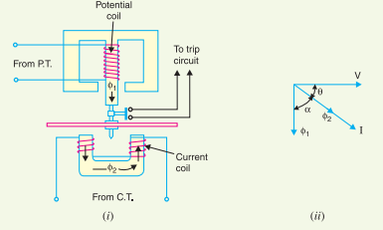

The spindle of the disc carries a moving contact which bridges two fixed contacts when the disc has rotated through a pre-set angle. By adjusting this angle, the travel of the moving disc can be adjusted and hence any desired time-setting can be given to the relay. Operation. The flux φ1 due to current in the potential coil will be nearly 900 lagging behind the applied voltage V. The flux φ2 due to current coil will be nearly in phase with the operating current I.

[See vector diagram in Fig.(ii)]. The interaction of fluxes φ1 and φ2 with the eddy currents induced in the disc produces a driving torque given by :

T ∝ φ1 φ2 sin α

Since φ1 ∝ V, φ2 ∝ I and α = 90 − θ

∴ T ∝ V I sin (90 − θ)

∝ V I cos θ

∝ power in the circuit

It is clear that the direction of driving torque on the disc depends upon the direction of power flow in the circuit to which the relay is associated. When the power in the circuit flows in the normal direction, the driving torque and the restraining torque (due to spring) help each other to turn away the moving contact from the fixed contacts. Consequently, the relay remains inoperative. However, the reversal of current in the circuit reverses the direction of driving torque on the disc. When the reversed driving torque is large enough, the disc rotates in the reverse direction and the moving contact closes the trip circuit. This causes the operation of the circuit breaker which disconnects the faulty section.

**Induction Type Directional Overcurrent Relay:**

The directional power relay discussed above is unsuitable for use as a directional protective relay under short-circuit conditions. When a short-circuit occurs, the system voltage falls to a low value and there may be *insufficient torque developed in the relay to cause its operation. This difficulty is overcome in the directional overcurrent relay which is designed to be almost independent of system voltage and power factor.

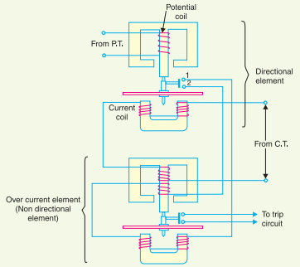

Constructional details: Above Fig. shows the constructional details of a typical induction type directional ovecurrent relay. It consists of two relay elements mounted on a common case viz. (i) directional element and (ii) non-directional element.

(i) Directional element. It is essentially a directional power relay which operates when power flows in a specific direction. The potential coil of this element is connected through a potential transformer (P.T.) to the system voltage. The current coil of the element is energised through a C.T. by the circuit current. This winding is carried over the upper magnet of the non-directional element. The trip contacts (1 and 2) of the directional element are connected in series with the secondary circuit of the overcurrent element. Therefore, the latter element cannot start to operate until its secondary circuit is completed. In other words, the directional element must operate first (i.e. contacts 1 and 2 should close) in order to operate the overcurrent element.

(ii) Non-directional element. It is an overcurrent element similar in all respects to a non-directional overcurrent relay. The spindle of the disc of this element carries a moving contact which closes the fixed contacts (trip circuit contacts) after the operation of directional element.

It may be noted that plug-setting bridge is also provided in the relay for current setting but has been omitted in the figure for clarity and simplicity. The tappings are provided on the upper magnet of overcurrent element and are connected to the bridge.

Operation. Under normal operating conditions, power flows in the normal direction in the circuit protected by the relay. Therefore, directional power relay (upper element) does not operate, thereby keeping the overcurrent element (lower element) unenergised. However, when a short-circuit occurs, there is a tendency for the current or power to flow in the reverse direction. Should this happen, the disc of the *upper element rotates to bridge the fixed contacts 1 and 2. This completes the circuit for overcurrent element. The disc of this element rotates and the moving contact attached to it closes the trip circuit. This operates the circuit breaker which isolates the faulty section. The two relay elements are so arranged that final tripping of the current controlled by them is not made till the following conditions are satisfied :

(i) current flows in a direction such as to operate the directional element.

(ii) current in the reverse direction exceeds the pre-set value.

(iii) excessive current persists for a period corresponding to the time setting of overcurrent element

Directional Over Current & Non Directional Over Current Protection Working Principle:

Directional Earth Fault Relay is used to protect the transformer/generator/alternator from over current fault. The relay sense the fault current in only one direction, the relay does not operate when the current in opposite direction. Due to high cost, the Directional Earth fault Relays are used only of high sensitive electrical machine such as alternator & High voltage transmission lines.

Non Directional & Directional Over Current Relay Explanation:

**Case: 1**

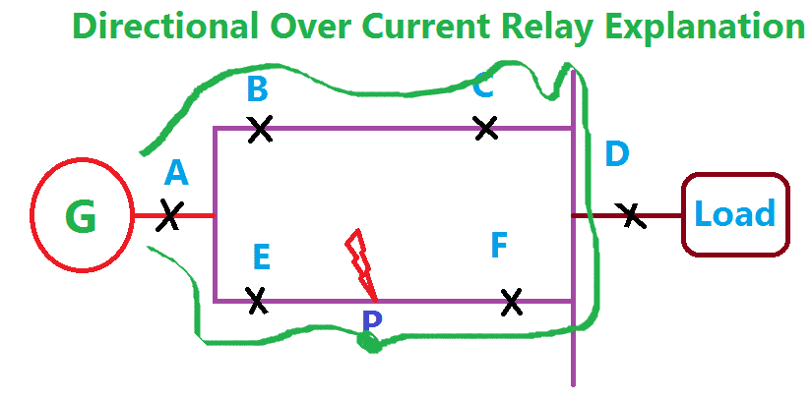

Consider a Power system consists of 6 circuit breaker A, B, C, D, E and F. In this, A, B, C, E are the Non directional over current relays and D, F is a directional over current relay. Consider a fault occurs at a point P. **You should remember one thing first, the current always flow through the low impedance path.** Hence the fault current flows from the generator G through the breaker A and E. Also the fault current comes from the breaker series A, B, C, and F. In this, the directional relay F operates the breaker of F, but the remaining all relay operates the respective circuit breaker in non-directional relay. Here the directional Relay D become in operative, because the load only observes the current.

**Case 2:**

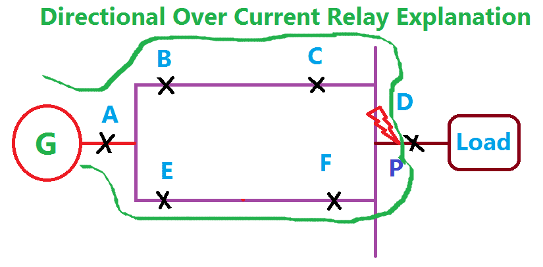

Now the fault occurs at a point P which is nearer to the load. In this case, the fault current flow from the generator through A, B, C, P, & A, E, F, P. In this condition, the relay A, B, C & E operates their respective breaker in Non-directional operation. D & F become in operative.

**Earth Fault Relay (EFR)**

**It is a safety device used in electrical installations with high earth impedance. It detects small stray voltages on the metal enclosures of electrical equipment. The result is to interrupt the circuit if a dangerous voltage is detected. The EFR is protected against tripping from transients and prevents shock.**

**The following figure shows the Earth Fault Relay –**

